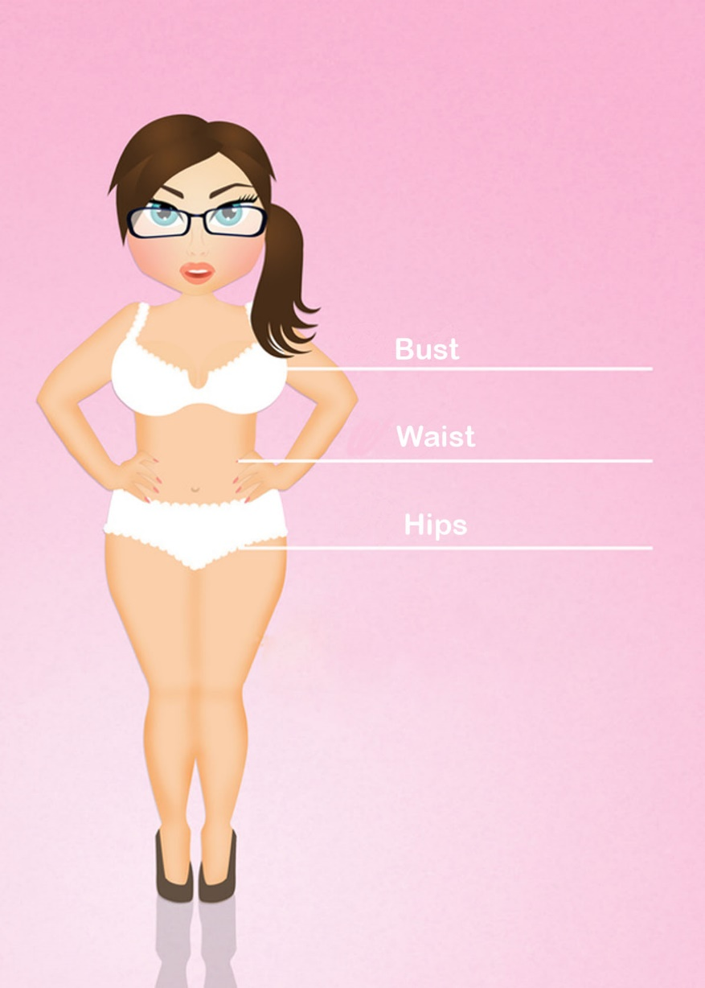
How to take your measurements
Measure yourself with your underwear on.
For all measurements make sure you do not pull the tape too tight.
Keep the tape parallel to the floor. Do not let it drop at the back.

Bust
Wrap the tape around the fullest part of your bust.

Waist
Your natural waist is at the narrowest part of your torso.

Hips
Learn Sewing Online
Size Chart Metric
 | 6 | 8 | 10 | 12 | 14 | 16 | 18 | 20 | 22 | 24 | 26
Bust | 85 | 90 | 95 | 100 | 105 | 110 | 115 | 120 | 125 | 130 | 135
Waist | 70 | 75 | 80 | 85 | 90 | 95 | 100 | 105 | 110 | 115 | 120
Hips | 90 | 95 | 100 | 105 | 110 | 115 | 120 | 125 | 130 | 135 | 140
Size Chart Imperial
 | 6 | 8 | 10 | 12 | 14 | 16 | 18 | 20 | 22 | 24 | 26
Bust | 33.5 | 33.5 | 37.5 | 39.5 | 41.5 | 43.5 | 45.5 | 47.25 | 49.25 | 51.25 | 53.25
Waist | 27.75 | 29.5 | 31.5 | 33.5 | 35.5 | 37.5 | 39.5 | 41.5 | 43.5 | 45.5 | 47.25
Hips | 35.5 | 37.5 | 39.5 | 41.5 | 43.5 | 45.5 | 47.25 | 49.25 | 51.25 | 53.25 | 55.25
Measure the widest part of your hips. This is approximately 20cms below your waist.

